Step 4: Fine map the coordinates of each exon on your contig gene isoform.

Introduction:
The exon coordinates that you determined from the BLAST mapping in Step 3 are “rough” coordinates, to map the exact coordinates of the exon intron junctions, you will use your BLAST crude mapping results from last week to zoom in on the correct areas, then proceed to fine-map the exon coordinates.

Objective:
- In this lab you will use the blast alignment of your contig protein to the D. melanogaster exons and the UCSC genome browser to closely examine the evidence for splice sites, mRNA seq data, and predicted exon boundaries from the ab initio gene predictor programs to find the exact beginning and end of each exon

Resources needed:
- Your contig: ______47________
- Gene name (and isoform if applicable): _ D. ananassae _ Sep. 2019 (GEP/Muller F Element)_____
- Your Crude exon coordinates and reading frame from Step 3 (coordinates table)
- GEP UCSC Genome Browser: http://gander.wustl.edu

Methods:
- Navigate to your assigned contig through the” Bioinformatics Project 2020_modified” hyperlink. Alternatively see the addendum to this assignment to retrieve your contig. Navigate to your contig/D melanogaster BLASTX alignment,
- Configure the Evidence tracks as in steps 4 and 5 in the Addendum to this document
- Zoom in to the predicted start of exon 1. You can also enter “Contig#: coordinate number” in the “enter position or search terms” window. Use the coordinate number from your crude mapping for the beginning of the exon. Then zoom out 3x and 10x to examine the first exon’s start site. Confirm the base position of the start codon (must code for Methionine) in the reading frame predicted in your last assignment “Step 3” and write this fine-map coordinate in the table provided below. Take a screen shot of the Genome Browser at the start codon for your report. Annotate the screen shot and describe in a caption below the screen shot.
- Examine the evidence from all the appropriate tracks: BLASTX. Ab initio gene predictions, and RNA Seq data.
- One splice junction at a time, zoom in to the exon-intron boundary predicted by BLAST. Look for the appropriate splice donor/splice acceptor sequence (GT or AG).
- Highlight on the screenshots ALL possible sites within 15 nucleotides on either side of the exon-intron boundary predicted by BLAST. For each possible splice site, consider the evidence that supports it (question 5 below). Based on the preponderance of the evidence, record the EXACT base coordinates of each exon in the table (below), being sure to mention the phase of each splice junction (both the beginning and end of the exon).
- Include a screen shot of each exon/intron junction, including about 15 bases on either side, in your report. Annotate the screenshots by “Boxing” in the splice donors, acceptors, start site and stop codons. Label and describe all your figures with captions.
- At the end of the last coding exon, locate the stop codon. Record the position of the last amino acid codon, and the 3-nucleotide coordinates of the stop codon. Take a screen shot.
- Save your Word document periodically, and back it up.

Questions (insert texts and images as needed annotate and label all your images)

- (2 points) What is the exact base coordinate of the A in your ATG START codon? The most common start codon is AUG.
- (20 points) Fill in the table below with the information from the Genome Browser. You also need to take screenshots of each exon/intron junction with around 15 bases on either side of the junction, you can put these screenshots under question 4. If the box in the table says N/A then you do not need to fill out a value for that box.
Coding Exon | Phase at the start of your exon | Phase at end of exon | GT donor site coordinates | AG acceptor site coordinates | Last base of Exon | Overall Fine map coordinates for full exon | Support for GT site | Support for AG site | Frame
1 | N/A | KRLK | 3133627 | N/A | MQSK | 5292526 | 241 | N/A | -1
2 | MKKNT | KRLK | 2176038 | 2175163 | MQSK | 5561815 | 241 | 292 | +1
3 | MKKNT | KRLK | 3200674 | 3201549 | MQSK | 5365433 | 241 | 292 | -1
4 | MKKNT | KRLK | 3132752 | 3133627 | MQSK | 5292526 | 241 | 292 | -1
5 | MKKNT | KRLK | 3132752 | 3133627 | MQSK | 5292526 | 241 | 292 | +1
6 | MKKNT | KRLK | 3108469 | 3109344 | MQSK | 5427594 | 241 | 292 | -1
7 | MKKNT | KRLK | 3258638 | 3259513 | MQSK | 5491935 | 241 | 292 | -3
8 | MKKNT | KRLK | 3132752 | 3133627 | MQSK | 5292526 | 241 | 292 | -1
9 | MKKNT | KRLK | 3749481 | 3750356 | MQSK | 5914775 | 241 | 292 | -1
10 | MKKNT | N/A | N/A | 3750356 | MQSK | 5914775 | N/A | 292 | -1

- (2 points) Record the position of the last amino acid codon and the three nucleotide coordinates of the stop
codon and take a screen shot STOP CODON.
Molecule type
The three STOP codons are amber (UAG), opal or umber (UGA) and ochre (UAA).

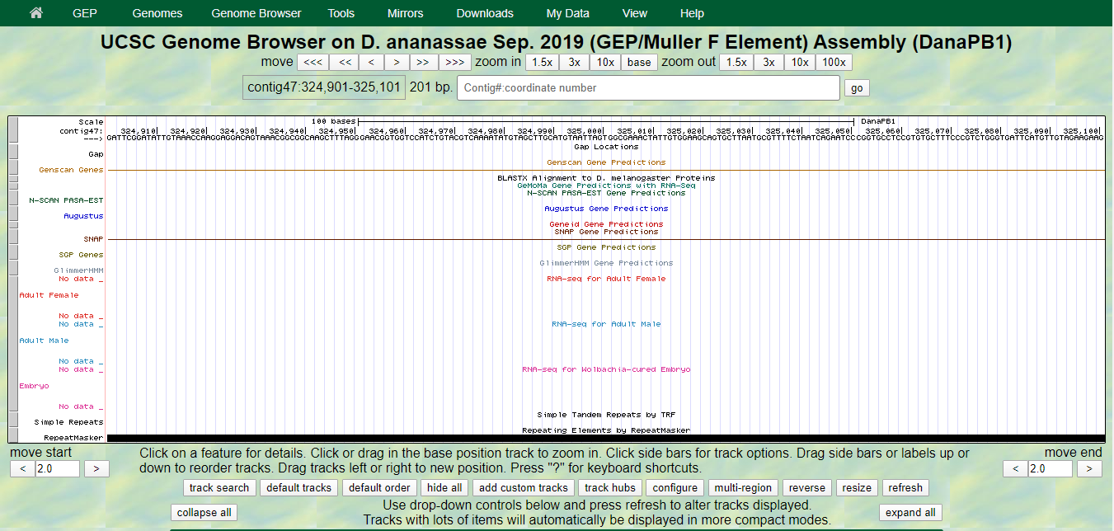

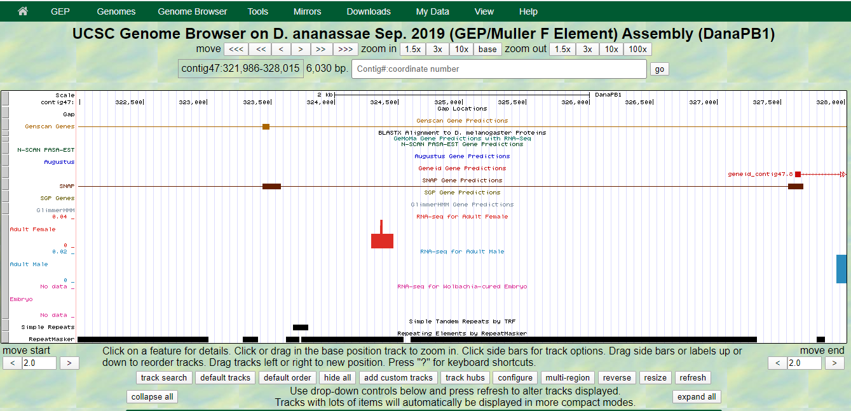

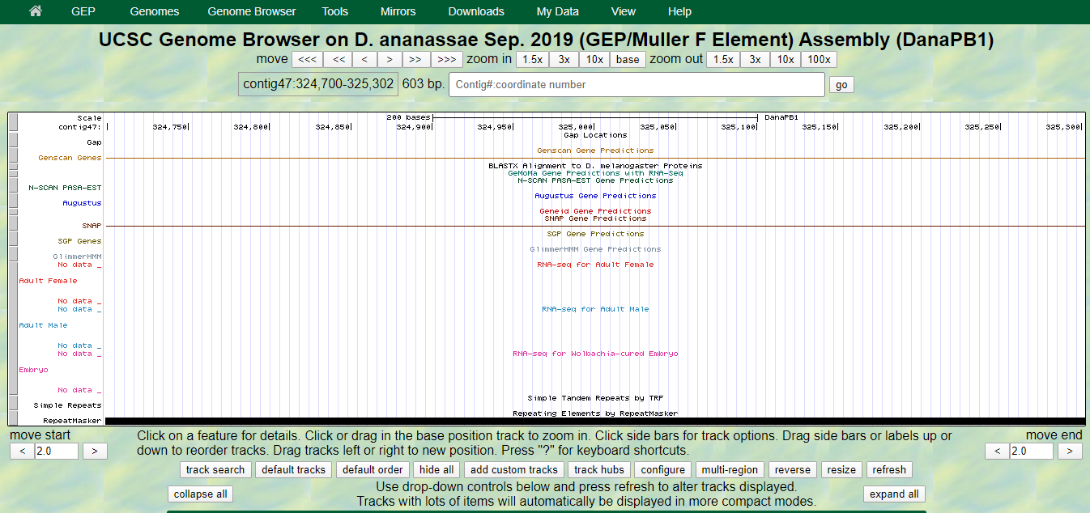

- (10 points) Screenshots of each intron/exon junction with the appropriate annotations, labels and captions

Exon 1 nucleotide
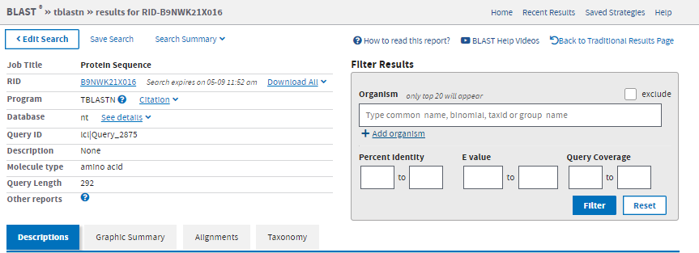
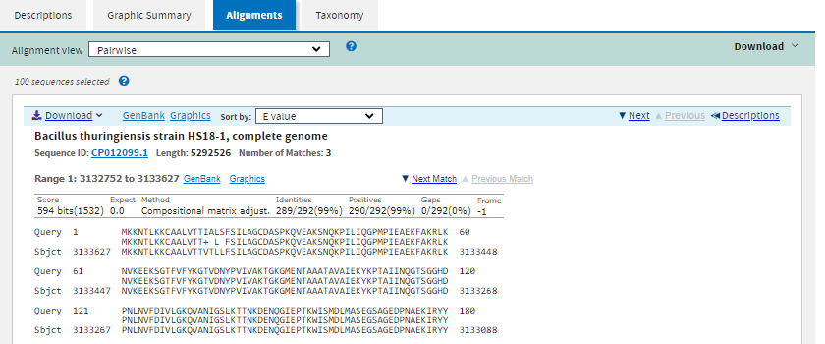
Exon 2 nucleotide
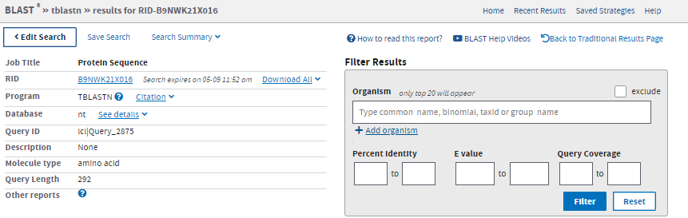

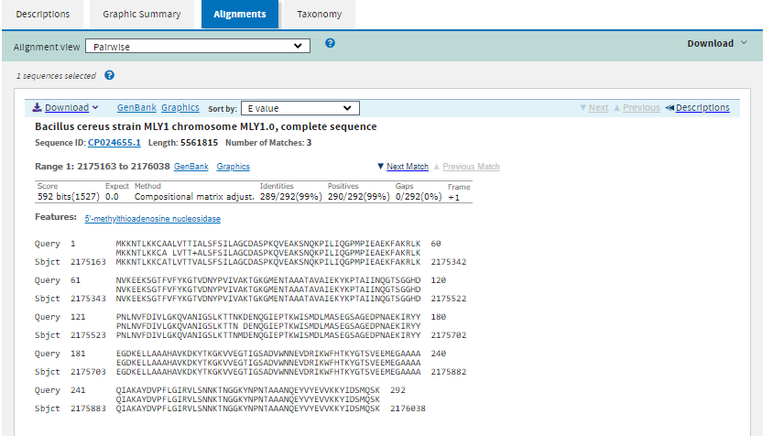

Exon 3 nucleotide
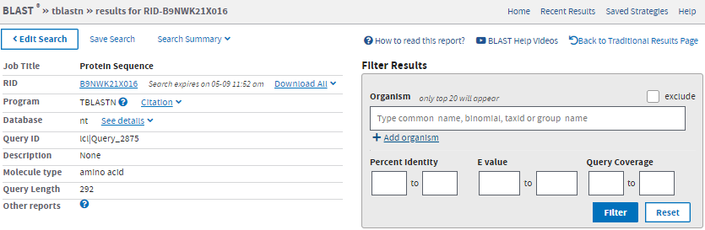
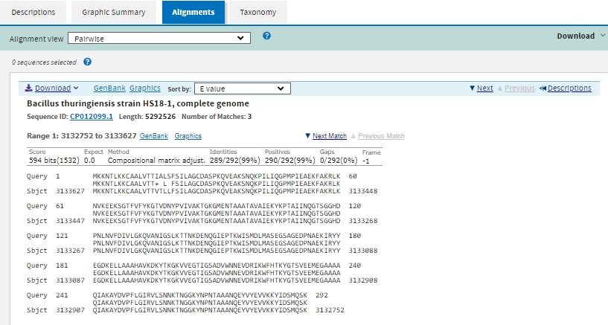
Exon 4 nucleotide
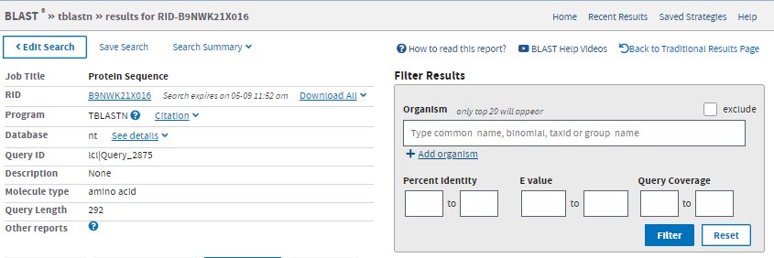
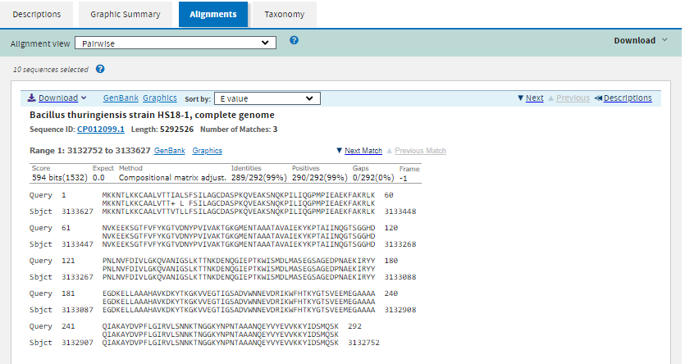
Exon 5 nucleotide
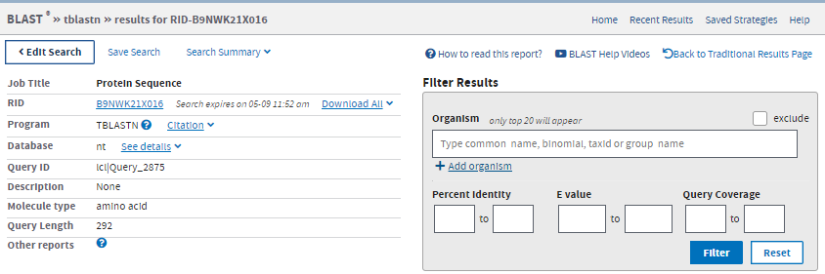
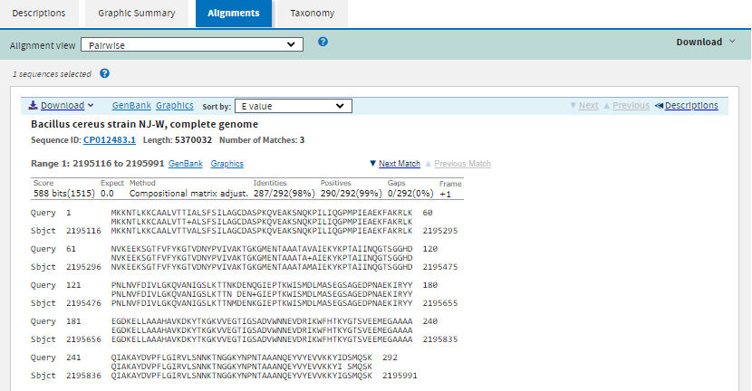
Exon 6 nucleotide
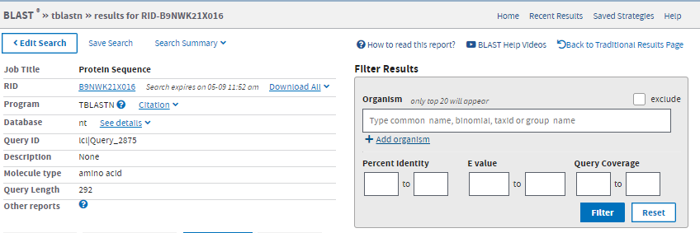
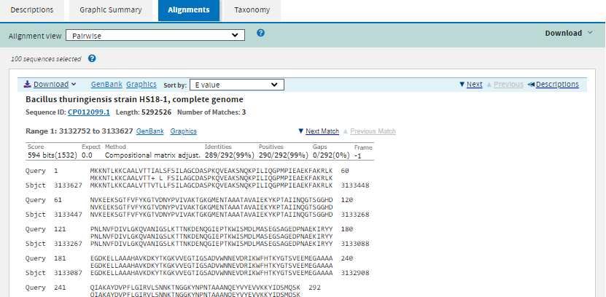
Exon 7 nucleotide
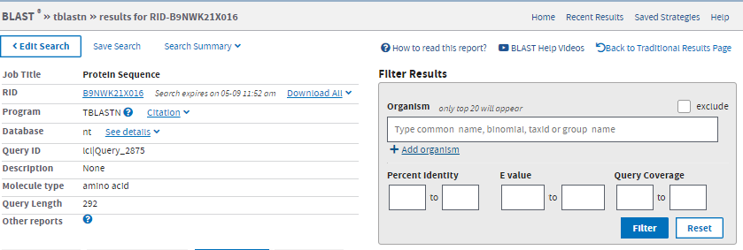
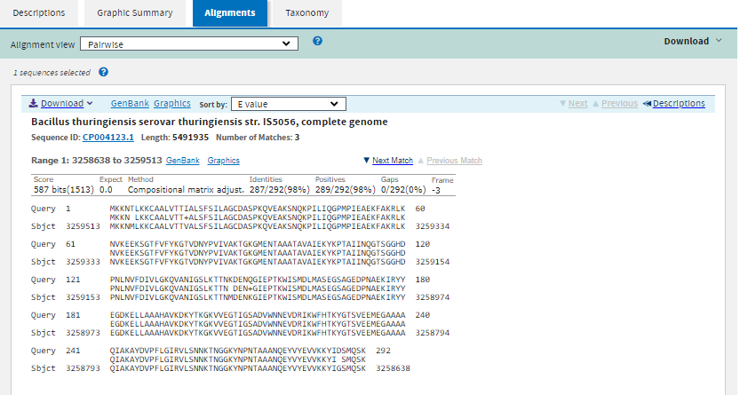
Exon 8 nucleotide
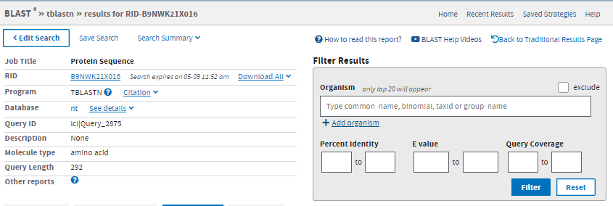
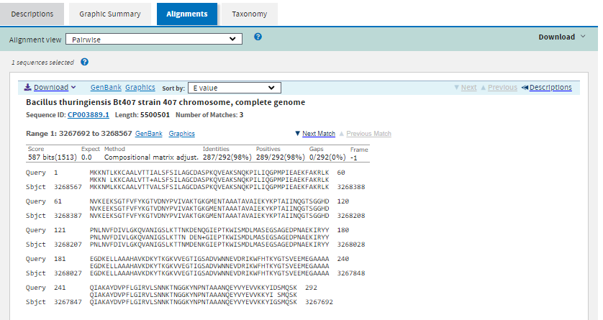
Exon 9 nucleotide
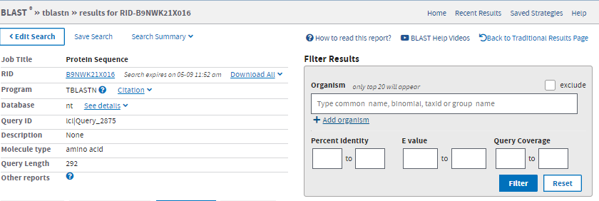
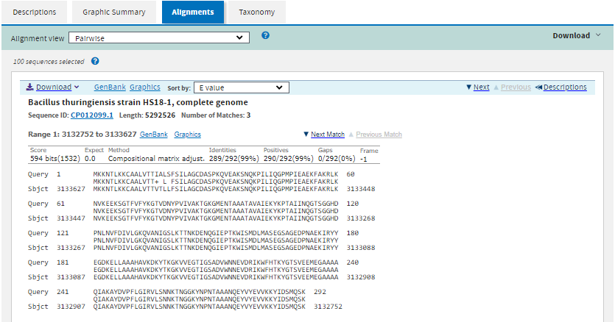
Exon 10 nucleotide
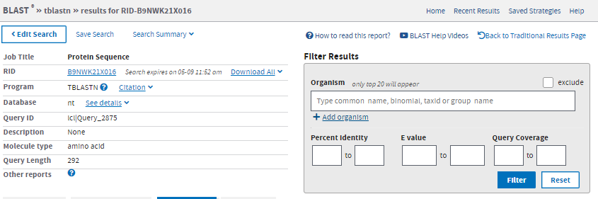

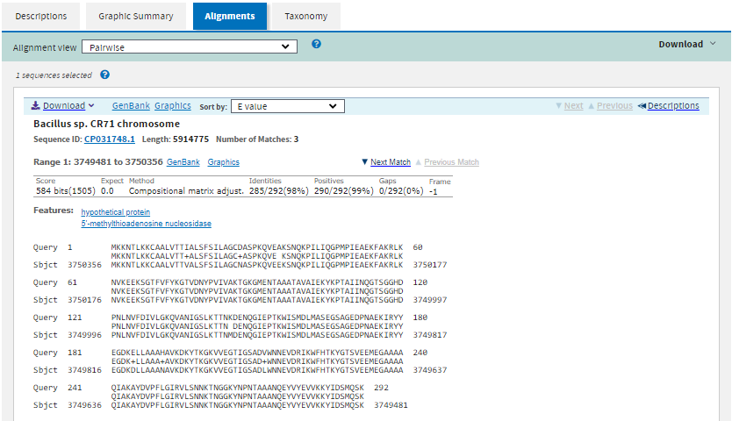

- (8 points)For each of your Exon/splice junctions, support your decision making using the evidence tracks and the alignments Below: Answer these questions after each screen shot showing your exon ends.
  - exon-by-exon BLAST search, (crude map)
This menu is automatically occupied with recent BLAST searches and allows someone enter Query Sequence.
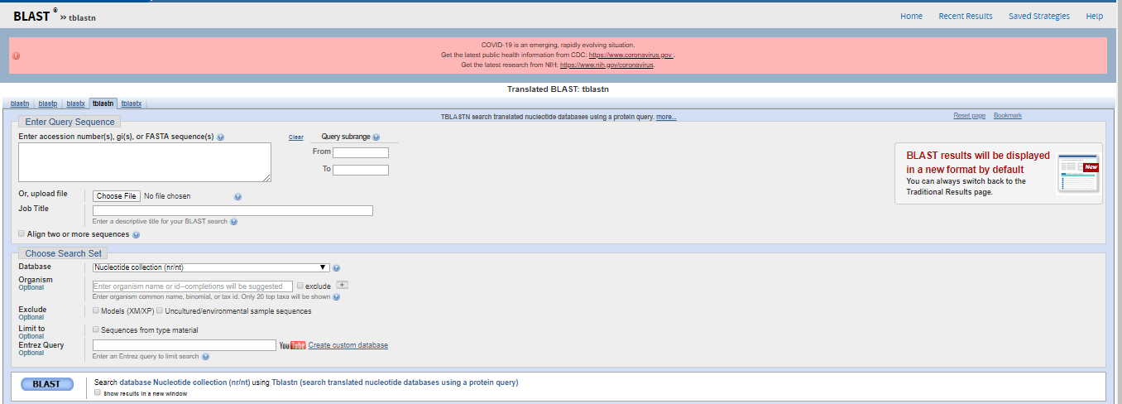
  - BLASTx alignment to melanogaster proteins,
The raw BLAST hits are provided by the former connecting exon hits together.
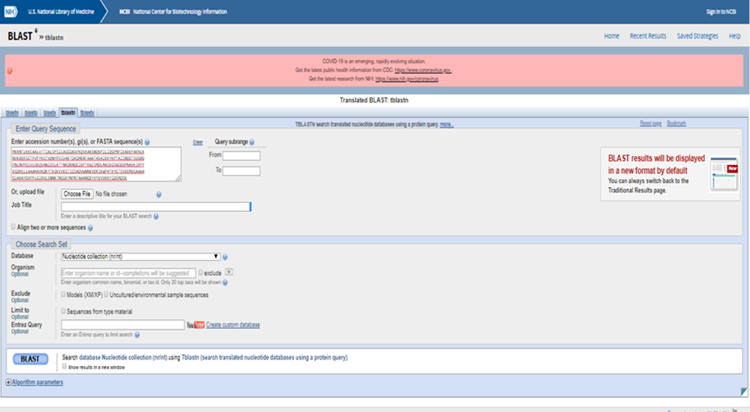
  - ab initio gene predictions,
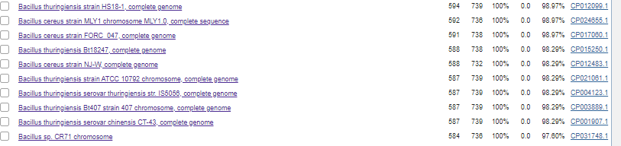
Ab initio gene prediction method.
Define parameters of real genes based on experimental evidence.
The first group uses an ab initio approach to predict genes directly from nucleotide sequences.

  - Has predicted consensus splice site,
Using different exons.
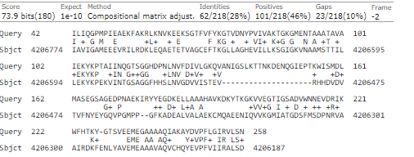
  - RNA-Seq data, drops off at this site,
and expected nucleotide distribution surrounding the 5' fragmentation site.
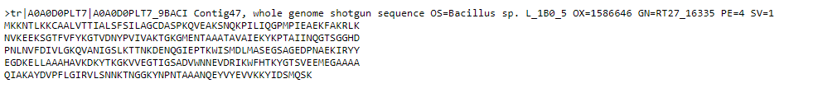
  - TopHat Junctions, (not available for D. ananassae)
The F element has undergone an expansion revealing a truncation missing ~31 amino acids.
Tophat junctions and Oasis transcripts support additional upstream exons, there is.
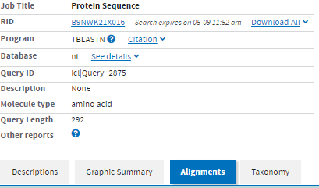
  - matching phase to the splice junction on the other side of the intron
on both the intron and exon sides of each splice junction in our databases.
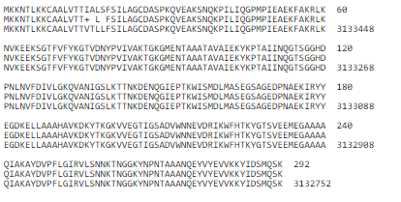
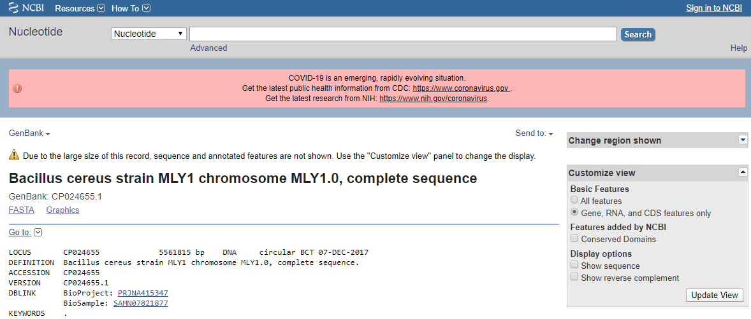
  - Other please specify

The National Center for Biotechnology Information advances science and health by providing access to biomedical and genomic information.
- (8 points) In the schematic, label the position(s) of each of the following: translation start, splice donor, splice acceptor, and translation stop. Remember, we are only annotating protein- coding sequences (no 5’ or 3’ UTRs).
Exon 4

Exon 1
Exon 2
Exon 3
Translation stop
Translation Start

Translation Stop
Slice Donor

